Hi! Thanks a lot for applying on this position! We would like to know more about your automation skills and that's why we have small automation task for you. You will have one week (7 days) to finish it and send it to us. If you will be able to finish it before – you could send it earlier. So here is a task:
- Please create new repo in GitHub (if needed – register your new user) – this repo will be used to share your project with us.
- Initiate new Node.js project (install ‘node’ and ‘npm’ if needed). More details could be found here - https://developer.mozilla.org/en-US/docs/Learn/Server-side/Express_Nodejs/development_environment
- Install Cypress test automation framework. More details here - https://docs.cypress.io/guides/getting-started/installing-cypress
- Write automated test which is:
- Going to the website https://weather.com

- Opening main menu:

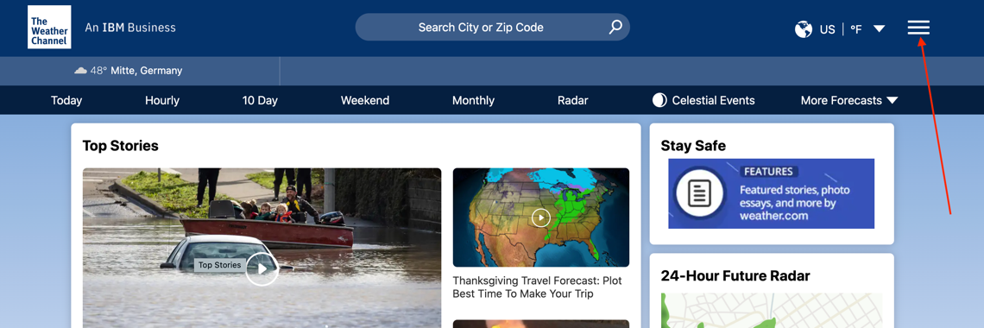

- Opening “Privacy Policy” page:

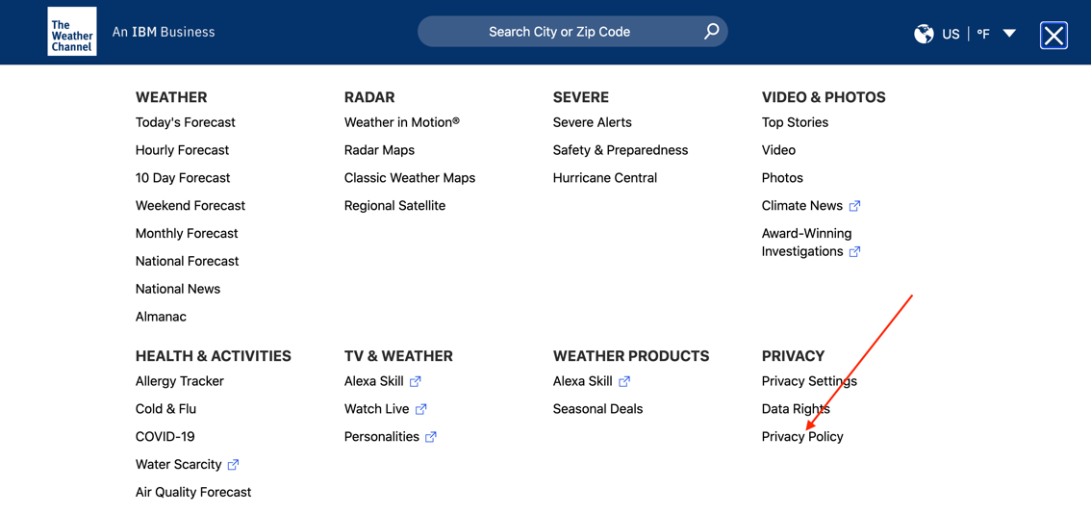
- On “Privacy Policy” page please verify that section 14 is available on page and has correct text (purpose of this test to check that for example with each new version of web app text is still in place and wasn’t corrupted):
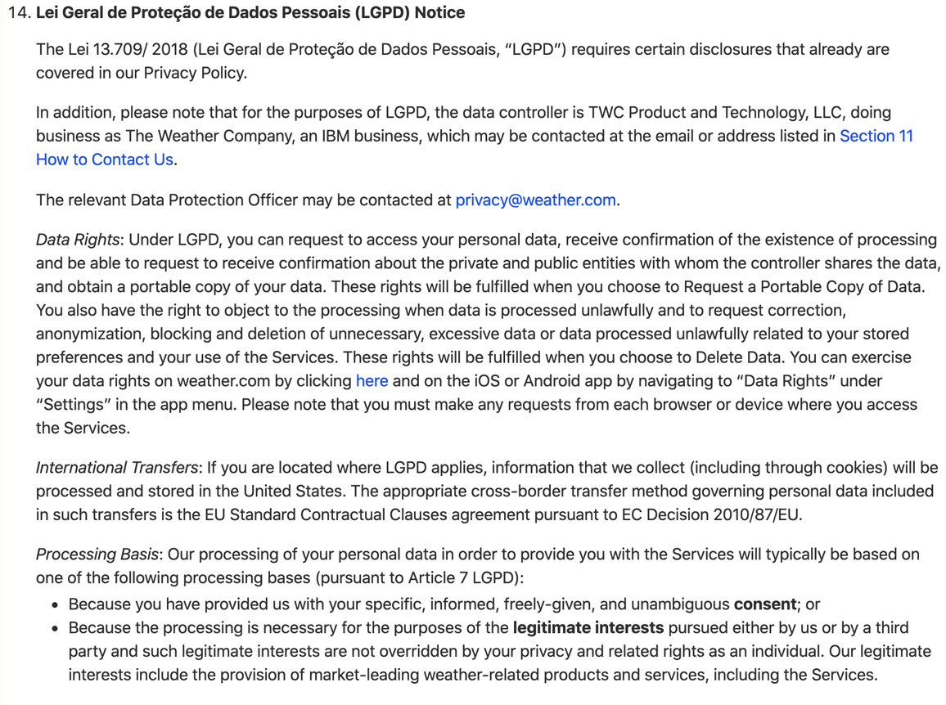
- Save your test, commit it and push to the newly created repo
- Share with us your project

If anything will not be clear during implementation of this task – feel free to ask us. Good luck and looking forward!

